Supplementary Materials

S1 Comparison with unsupervised learning methods
The comparison of our model and the unsupervised learning method proposed by Gan et al. [1] is conducted with visualization. The optical strain values between the first frame and the subsequent frames were calculated in [1], then the peaks of the optical strain curve were searched. Fig. 1(a), (b) and (c) show the visualization comparison of three ground-truth expression intervals from the onset frame to the offset frame. The first row is the optical strain curve and the value represented by the y-axis is the optical strain value. The second row is our model curve and the value represented by the y-axis is the probability that the TWNet model predicts. From the comparison of the three groups of curves, it can be found that our model can better deal with the spotting task that contains great variance and complex MaE and ME intervals than the unsupervised learning method. It also guides our model to work better than unsupervised learning methods in most cases.
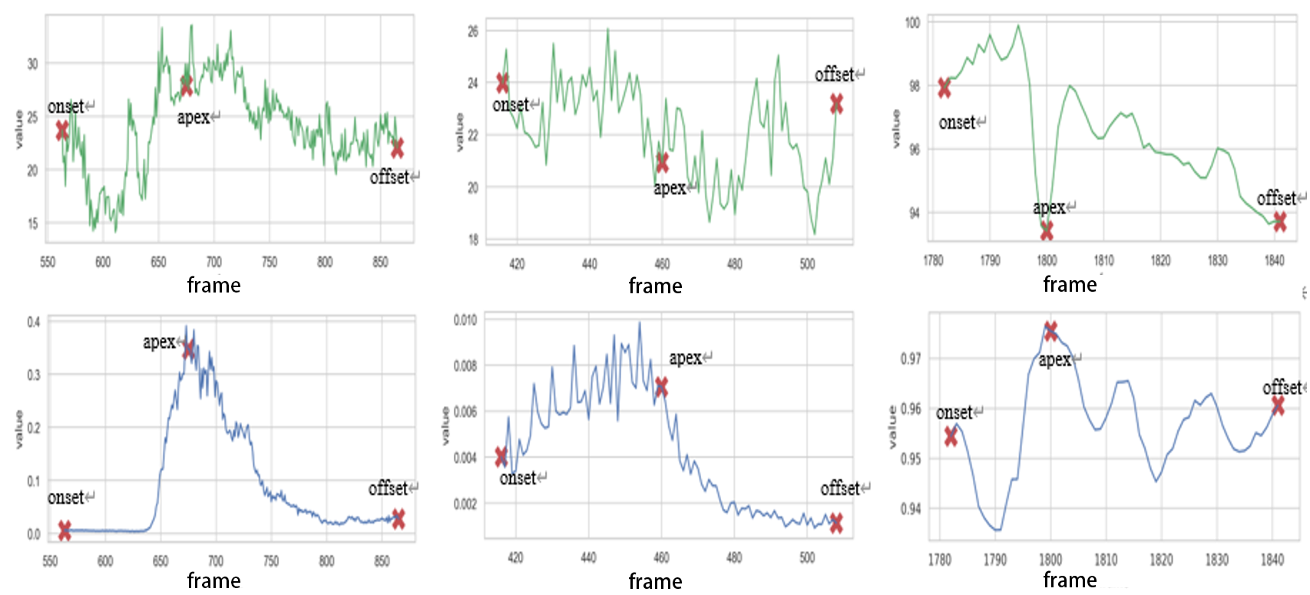

Onset Apex Offset Onset Apex Offset Onset Apex Offset
(a) SAMM 009_4 (MaE) (b) SAMM 017_6 (ME) (c) CAS(ME)² s38_0502 (MaE)
- The visualization comparison with unsupervised learning method. The first row is the curve of the unsupervised method, the second row is the curve predicted by our TWNet, and the third row is the display of the onset, apex, and offset frames of the expression interval
Furthermore, the effect of our network is compared with other networks in the static feature module from other perspectives. As illustrated in Fig. 2, TWNet distinguishes more TP intervals (MaE TPs +ME TPs) than other networks on both datasets.
Table 1 shows the Precision results on the two datasets, and it is found that TWNet gets the highest Precision scores on both datasets, which indicates that our model can find more TPs with fewer FPs. The success of our model mainly lies in its hierarchical feature extraction without shortcut connections, which reduces overfitting on limited data. The integration of residual blocks into the static module doesn’t benefit the performance of our model, as shown in Table 6. It is found that on small sample size of expression datasets, such as SAMM and CAS(ME)², residual connections introduce redundancy and overfitting, lowering F1-score about 3% in preliminary trials for both ResNet/ResAttentionNet.

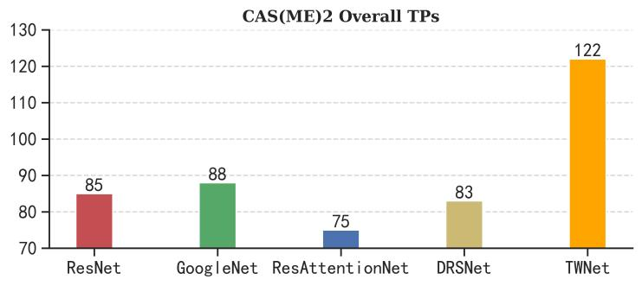
(a) Comparison on CAS(ME)²
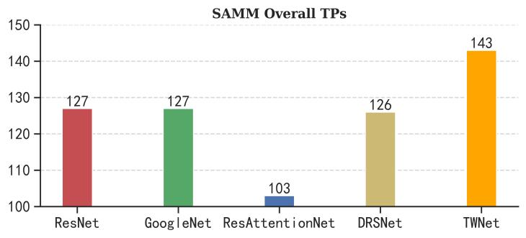
(b) Comparison on SAMM
- Comparison of the overall TPs with other networks on the two datasets
- Comparison of Precision with other networks on the overall results
Network of the Static feature module | CAS(ME)² | SAMM
ResNet [2] | 0.0416 | 0.0906
GoogleNet [3] | 0.0325 | 0.0966
ResAttentionNet [4] | 0.0309 | 0.0798
DRSNet [5] | 0.0328 | 0.0741
TWNet | 0.0487 | 0.119

The results in Table 2 show the mean overlapping percentages in comparison with the ground-truth intervals. As shown in Formular (11), the spotting interval is considered as TP when its overlapping percentages with the ground-truth intervals are greater than 0.5. We calculate the mean overlapping percentages (MOP) of overall TPs with the ground-truth intervals, and we can find that the MOP of TWNet is larger than the MOPs of other networks.
In consideration of the shallow depth of our modified VGG (5 convolutional layers) combined with aggressive dropout (applied after every pooling layer), it is confirmed that the simple structure of our model prevents overfitting on small expression datasets. ResNet's deeper architectures, while powerful for large-scale recognition, risk overfitting when transferred to limited spotting data. Besides, FER2013, our pre-training dataset, contains static expression images with significant noise. VGG's simpler structure learns robust mid-level features under noisy conditions, whereas ResNet's skip connections might propagate artifacts from low-quality samples.
The static module focuses on spatial details, while the dynamic module (optical flow) handles temporal motion. VGG's spatially focused design complements the dynamic features without redundancy, whereas ResNet's multi-scale features could overlap with optical flow patterns.

In short, our static feature model is far superior to other networks in all aspects of the spotting task.
- The MOP with the ground-truth intervals
Network of the Static feature module | CAS(ME)² | SAMM
ResNet [2] | 57.11% | 54.45%
GoogleNet [3] | 55.15% | 55.27%
ResAttentionNet [4] | 53.91% | 51.16%
DRSNet [5] | 55.15% | 55.71%
TWNet | 58.37% | 57.00%

S2 Further analysis of results
There are 97 video sequences of 22 subjects on the CAS(ME)² dataset, and 147 video sequences of 30 subjects on the SAMM Long Videos dataset. Tables 3 and 4 show the detailed results for each subject on the CAS(ME)² and SAMM datasets, respectively. V_{num} represents the number of video sequences belonging to the corresponding subject. It can be found that the F1-score indices of each subject are quite different. As for the subjects with video sequences that are identified with low F1-score indices, further investigations are carried out. It is also found that the subjects in those video sequences are of special characteristics or gestures, such as wearing glasses, bowing, skewing, and so on. These types of unusual appearances cannot be directly distinguished by our method. Therefore, some more strategies should be designed to solve these problems.
- The detailed results of every subject on the CAS(ME)² dataset
Subjects | V_{num} | MaE |  |  | ME |  |  | overall
Subjects | V_{num} | TP | FP | FN | TP | FP | FN | F1-score
s15 | 8 | 4 | 91 | 11 | 0 | 110 | 2 | 0.0360
s16 | 7 | 16 | 93 | 30 | 0 | 21 | 8 | 0.1739
s19 | 5 | 2 | 73 | 2 | 0 | 75 | 1 | 0.0258
s20 | 1 | 1 | 12 | 2 | 0 | 7 | 0 | 0.0870
s21 | 2 | 2 | 40 | 0 | 0 | 23 | 0 | 0.0597
s22 | 5 | 4 | 46 | 12 | 0 | 94 | 0 | 0.0500
s23 | 4 | 2 | 24 | 4 | 3 | 112 | 0 | 0.0667
s24 | 5 | 11 | 76 | 13 | 0 | 63 | 0 | 0.1209
s25 | 4 | 3 | 30 | 2 | 1 | 41 | 3 | 0.0952
s26 | 4 | 4 | 56 | 2 | 0 | 38 | 0 | 0.0769
s27 | 9 | 17 | 98 | 15 | 3 | 151 | 8 | 0.1282
s29 | 1 | 0 | 12 | 0 | 1 | 3 | 0 | 0.1176
s30 | 7 | 5 | 112 | 12 | 0 | 2 | 2 | 0.0725
s31 | 7 | 5 | 127 | 21 | 0 | 57 | 6 | 0.0452
s32 | 9 | 27 | 121 | 21 | 0 | 19 | 6 | 0.2443
s33 | 2 | 0 | 7 | 4 | 0 | 68 | 0 | 0
s34 | 3 | 0 | 75 | 3 | 0 | 12 | 0 | 0
s35 | 1 | 0 | 6 | 0 | 0 | 6 | 2 | 0
s36 | 2 | 0 | 44 | 4 | 0 | 6 | 0 | 0
s37 | 6 | 7 | 58 | 14 | 0 | 109 | 2 | 0.0711
s38 | 2 | 4 | 15 | 7 | 0 | 43 | 1 | 0.1081
s40 | 3 | 1 | 14 | 4 | 0 | 113 | 0 | 0.0150
- The detailed results of every subject on the SAMM dataset
Subjects | V_{num} | MaE |  |  | ME |  |  | overall
Subjects | V_{num} | TP | FP | FN | TP | FP | FN | F1-score
006 | 7 | 11 | 32 | 12 | 4 | 20 | 7 | 0.2970
007 | 5 | 3 | 11 | 2 | 5 | 23 | 5 | 0.2807
008 | 4 | 1 | 7 | 4 | 0 | 19 | 0 | 0.0625
009 | 5 | 1 | 0 | 5 | 1 | 19 | 3 | 0.1290
010 | 7 | 8 | 23 | 11 | 0 | 0 | 4 | 0.2963
011 | 7 | 17 | 56 | 29 | 1 | 31 | 19 | 0.2105
012 | 5 | 1 | 6 | 7 | 1 | 40 | 2 | 0.0678
013 | 5 | 6 | 18 | 8 | 1 | 33 | 5 | 0.1795
014 | 7 | 4 | 12 | 16 | 4 | 68 | 7 | 0.1344
015 | 5 | 3 | 13 | 12 | 0 | 23 | 3 | 0.1052
016 | 6 | 5 | 31 | 6 | 0 | 16 | 5 | 0.1471
017 | 6 | 2 | 6 | 4 | 1 | 19 | 5 | 0.1500
018 | 7 | 7 | 29 | 9 | 0 | 2 | 4 | 0.2414
019 | 6 | 6 | 15 | 8 | 1 | 15 | 2 | 0.2593
020 | 7 | 6 | 48 | 16 | 0 | 0 | 9 | 0.1412
021 | 2 | 1 | 7 | 1 | 0 | 7 | 2 | 0.1053
022 | 5 | 2 | 13 | 5 | 2 | 9 | 3 | 0.2105
023 | 2 | 0 | 2 | 1 | 1 | 5 | 0 | 0.2000
024 | 3 | 2 | 6 | 5 | 0 | 0 | 1 | 0.2500
025 | 4 | 2 | 11 | 3 | 2 | 17 | 2 | 0.1951
026 | 6 | 1 | 12 | 7 | 4 | 37 | 9 | 0.1333
028 | 1 | 2 | 1 | 0 | 0 | 3 | 3 | 0.3636
030 | 3 | 1 | 4 | 4 | 1 | 20 | 2 | 0.1176
031 | 1 | 0 | 0 | 0 | 0 | 2 | 1 | 0
032 | 5 | 3 | 3 | 7 | 0 | 33 | 6 | 0.1091
033 | 7 | 2 | 8 | 9 | 3 | 51 | 2 | 0.1250
034 | 3 | 1 | 2 | 3 | 1 | 19 | 2 | 0.1333
035 | 7 | 4 | 41 | 9 | 0 | 6 | 9 | 0.1096
036 | 4 | 7 | 25 | 10 | 0 | 33 | 1 | 0.1687
037 | 5 | 0 | 9 | 9 | 2 | 45 | 1 | 0.0588

Reference

[1] Y. Gan, S. Liong, D. Zheng, S. Li, and C. Bin, "Optical strain based macro-and micro-expression sequence spotting in long video," in Proceedings of the IEEE International Conference on Automatic Face and Gesture Recognition, Buenos Aires, Argentina, pp. 18-22, 2020.
[2] K. M. He, X. Y. Zhang, S. Q. Ren, J. Sun, and Ieee, "Deep Residual Learning for Image Recognition," presented at the 2016 IEEE/CVF Conference on Computer Vision and Pattern Recognition (CVPR), 2016.
[3] C. Szegedy, W. Liu, Y. Jia, P. Sermanet, S. Reed, D. Anguelov, D. Erhan, V. Vanhoucke, and A. Rabinovich, "Going deeper with convolutions," in Proceedings of the IEEE / CVF Computer Vision and Pattern Recognition Conference, pp. 1-9, 2015.
[4] S. Song, R. Zhang, Z. Qiu, J. Jin, and S. Yu, "Res-Attention Net: An Image Dehazing Network," in 2021 IEEE International Conference on Computer Science, Artificial Intelligence and Electronic Engineering (CSAIEE), pp. 200-205, 2021.
[5] F. Chen and J. Y. Tsou, "DRSNet: Novel architecture for small patch and low-resolution remote sensing image scene classification," International Journal of Applied Earth Observation and Geoinformation,vol. 104, p. 102577, 2021.

